# Sergii Voloshchuk Pizza project

I have created a 3-page web-site for ordering pizza. This site is creating for ordering pizza in really easy way. People can choose the pizza that they want and wait for delivering. For ordering pizza users must to choose what type of pizza they want, and select the size of pizza. Also, they need to provide their information, such as their names, address, phone number, e-mail, etc. After the pizza is selected and all needed information is presented, user needs to submit the order and wait 30 minutes for delivering the pizza.

## Order the pizza

On the very first page user sees the menu. He or she can select the pizza. There are 4 options (Pepperoni, Hawaiian, Greek Pizza +YOUR OWN PIZZA). When user click on each radio button, he/she will see that price changes dynamically on the right side of the web page. The ingredients for “build your own pizza” appears after user select “Add some ingredients ” radio button. There are 6 options for build your own pizza.(chicken, mushrooms, pineapple, bacon, tomatoes, garlic). User can also select the size of pizza(small, medium and large) and select the crust(thin or pan) and go forward by clicking “Submit your order” button. Screenshots from this page is below.

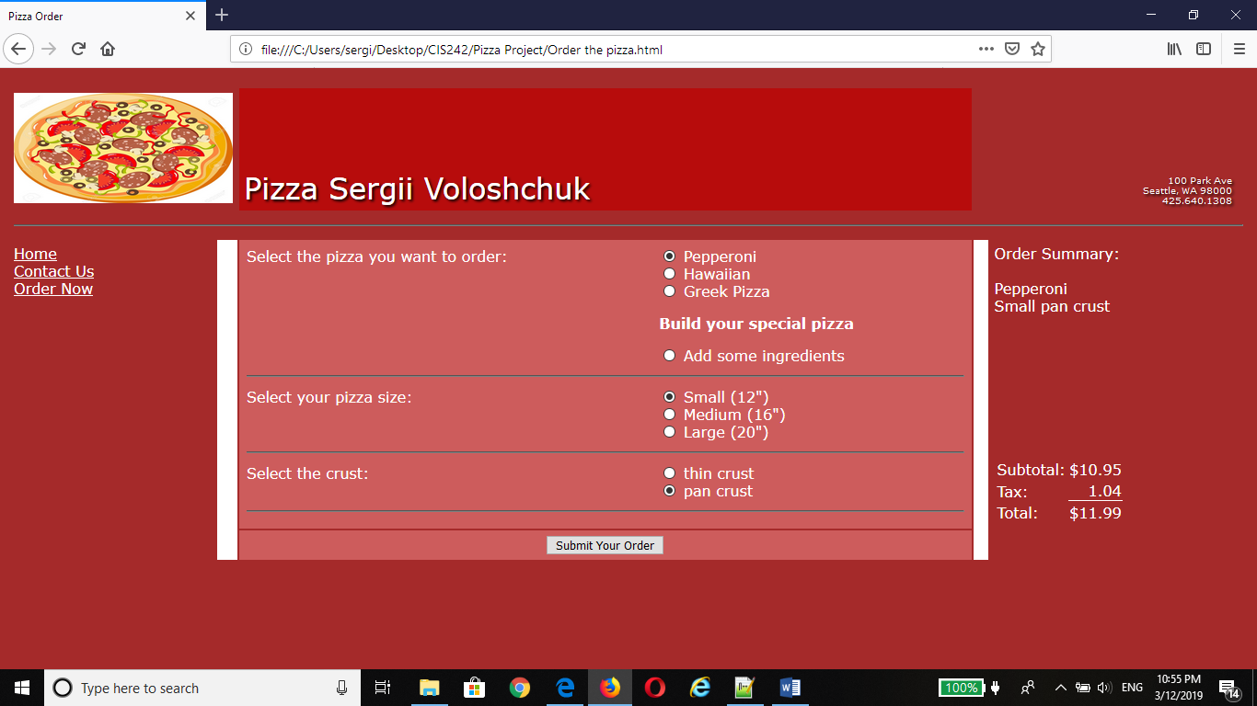

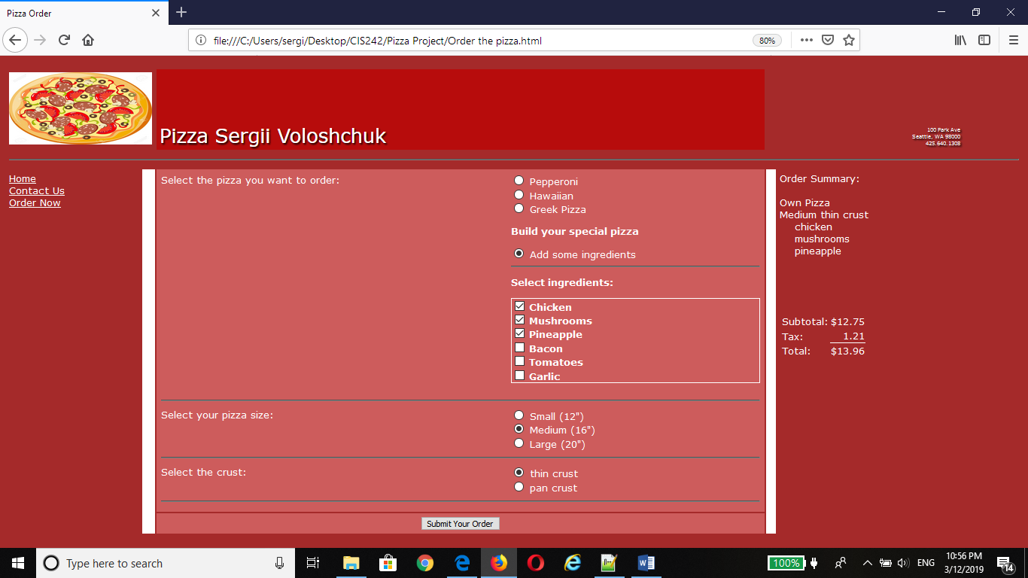

## Customer Information page

After the pizza is selected, customer needs to fill-out some fields. The information that is requested:

First Name, Last Name, Email, Address, Apartment # (if applicable), City, State, Zip. Every field is required except apartment #. When user miss a field, there is going to be a message about it. Customer cannot submit the order if required fields are not filled out or when email or phone number written not correctly. All mistakes that were made by customer will be displayed against the field, so customer can easily change it. The total price is saved at cookie file and displayed at each page.

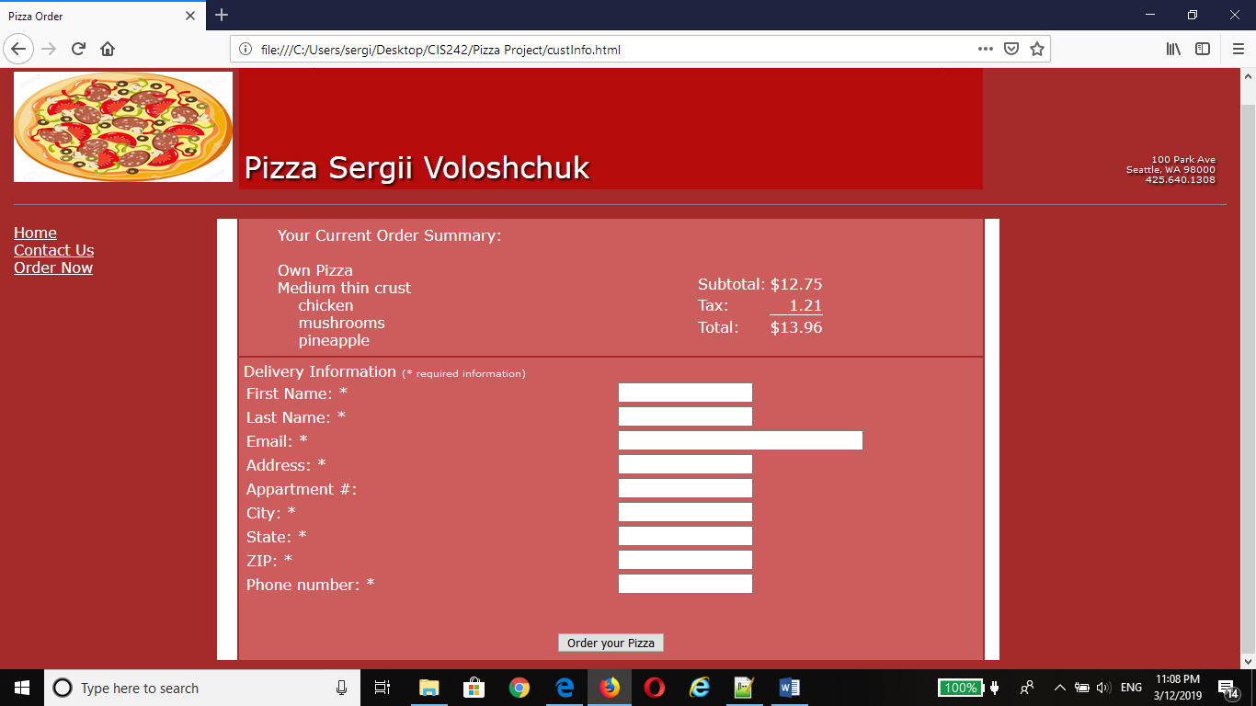

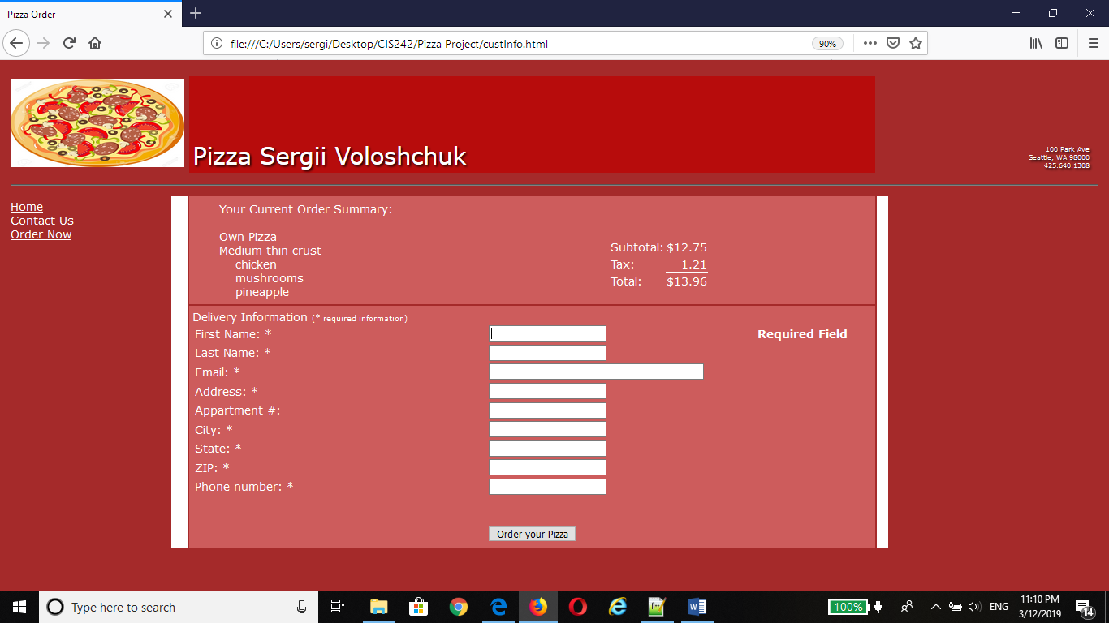

All fields are required except appartment #

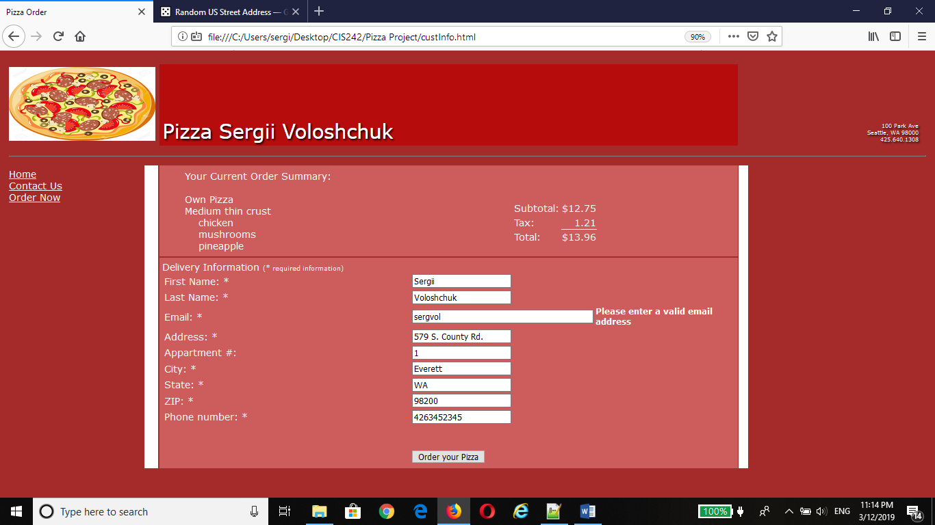

Email must be valid

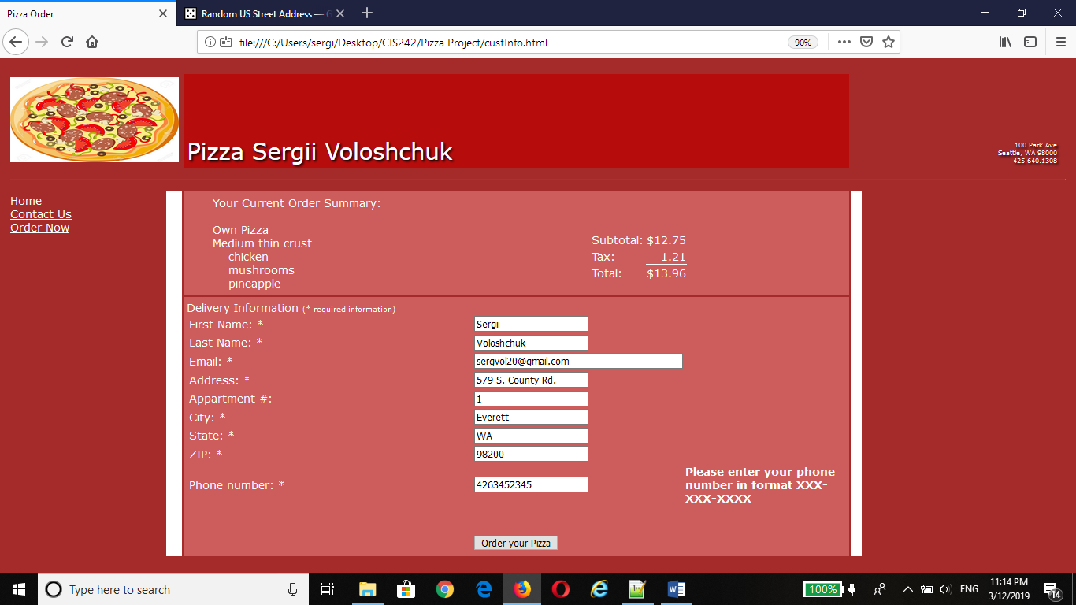

Phone number must be at format xxx-xxx-xxxx

## Summary page

The last page displays all the information about the pizza. It shows how much time left for pizza being delivered. The timer starts from 30 minutes and going backward. The page shows the address that costumed put on previous page, the pizza which was selected on the very first page and the total with tax.

